Applied Distributed Systems Project 2

Introduction:

This report contains the load testing and fault tolerance test results done on our Weather Data Service Application.
We have used Kubernetes to create replicas of our system services and deployed it on minikube through a single bash file.

Roadblocks :
Due to memory constraints, we could only create 4 replicas of our Radar service since we allocated its container 3GB RAM

Testing environment:
The testing for this application was done on Jmeter running in CLI and GUI modes. We have used laptops with 4 cores and 8 and 16 GB RAM’s respectively.

Test Scenarios :

A] Radar Micro-service Tests

1: Radar Service Test with 1 instance
Test Context : Service Tested Independently.
Ramp Up Period : 100 seconds
Threads/Users : 5

Results :
a) Non-cached images : The search parameters were searched for the first time by the user

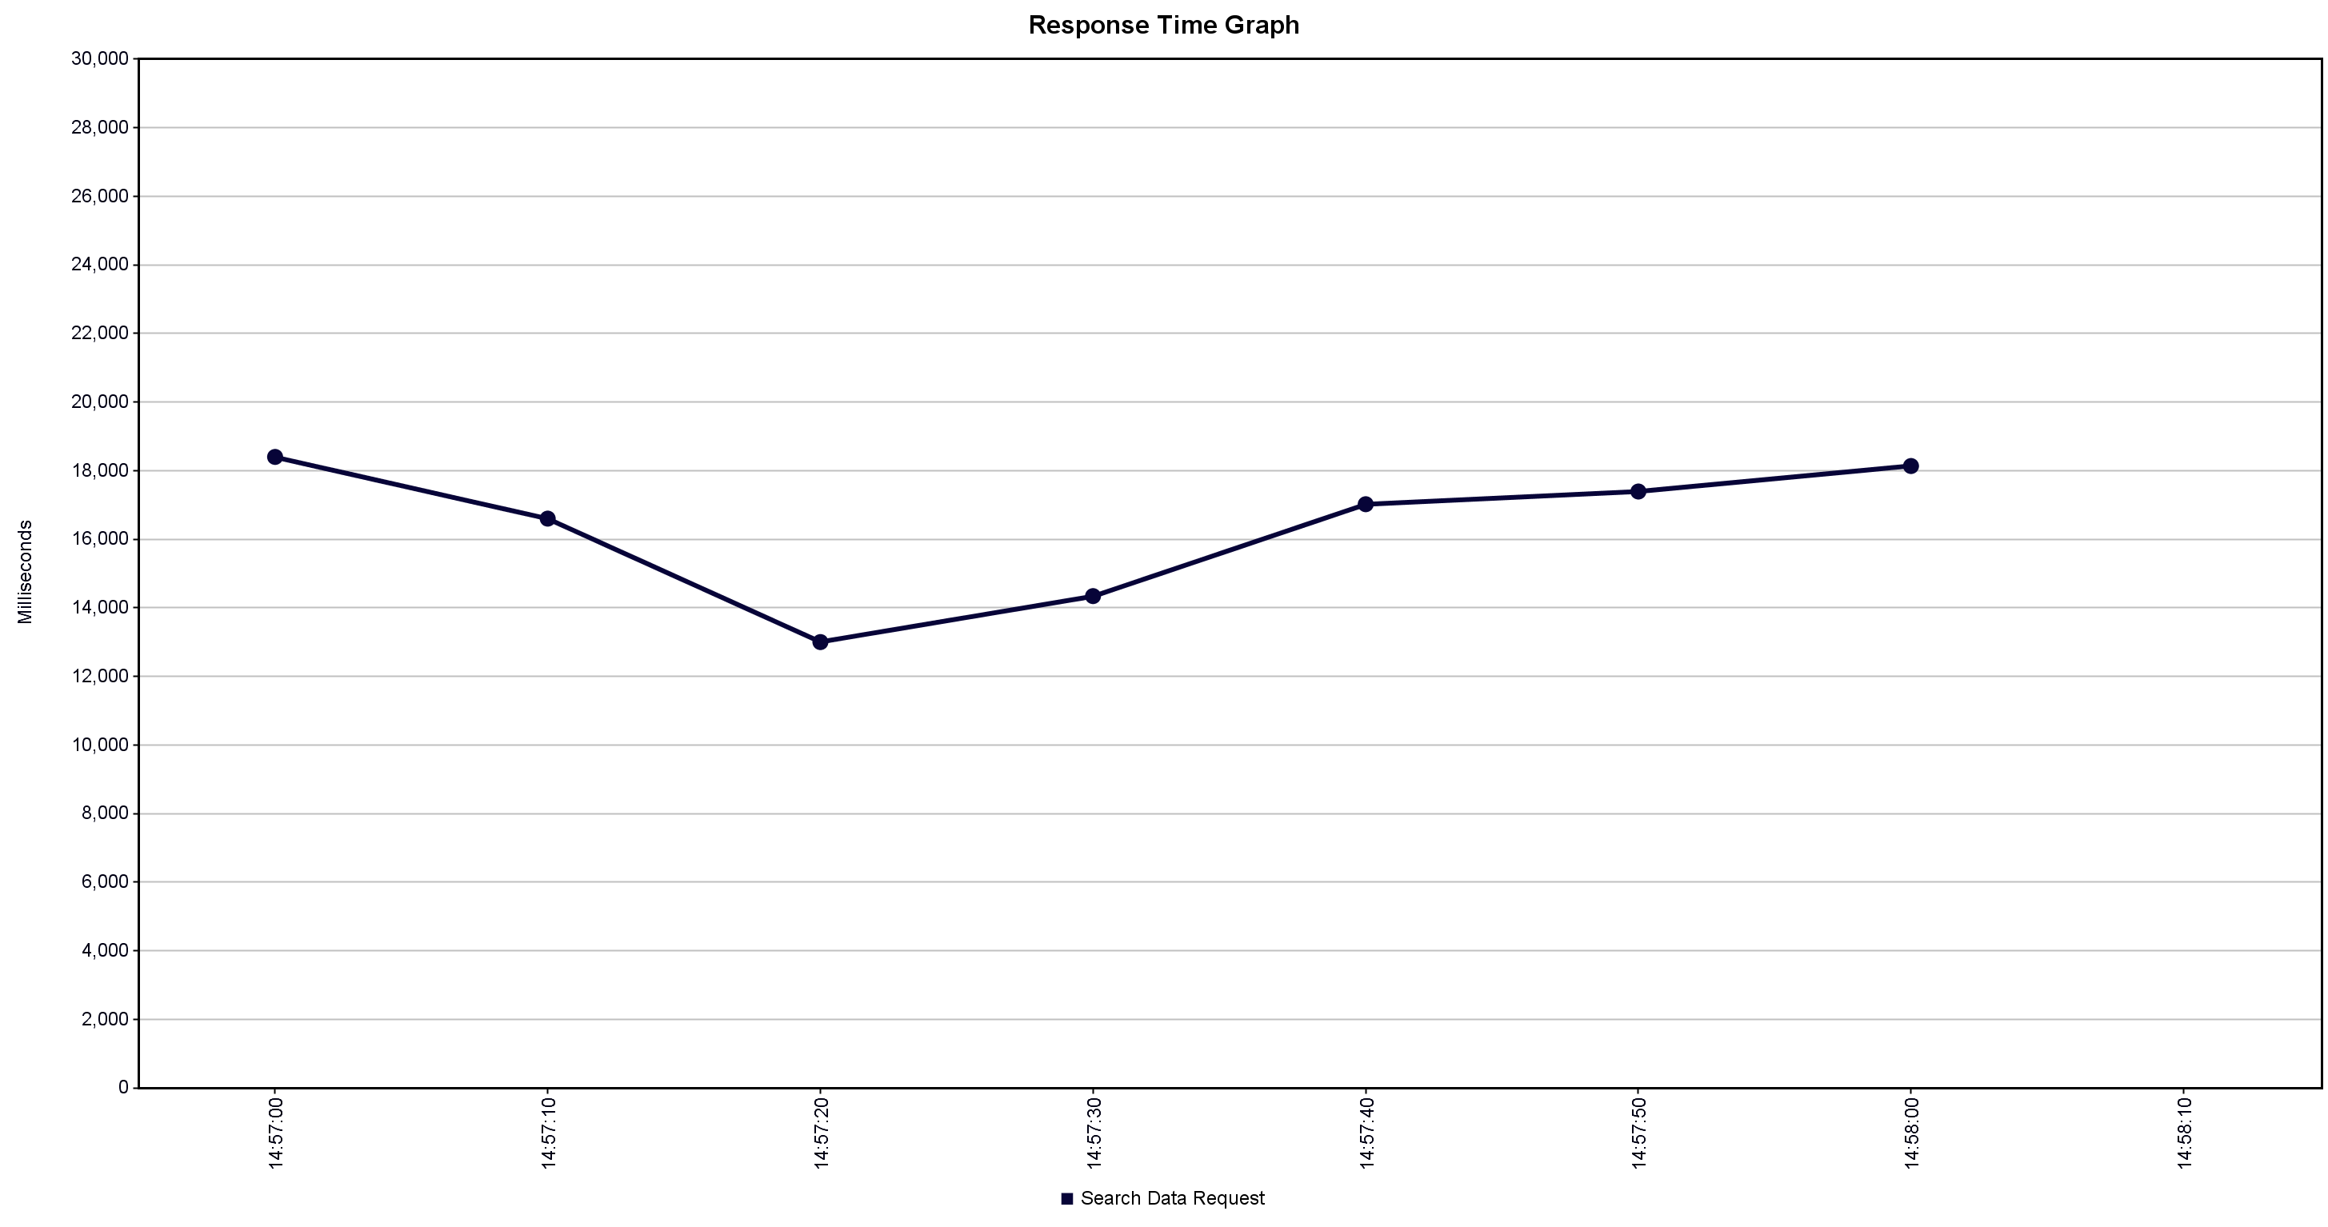

b) Cached Images : The search parameters have been cached and kept
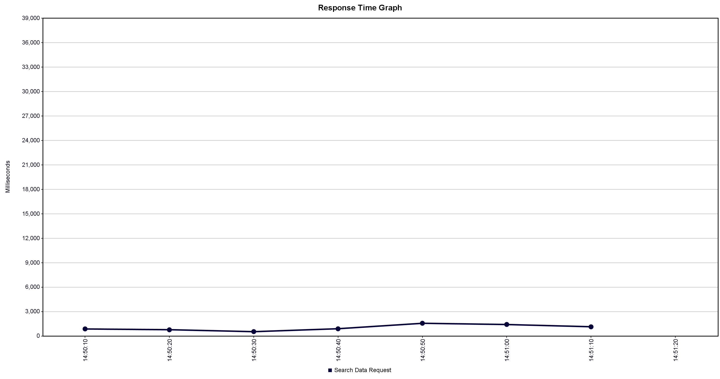

Tabular Results :

No of Users | Ramp Up | Comment
5 | 100 seconds | Steady response latency of 12 to 16 seconds
5 | 100 seconds | Response Latency of 1-3 seconds

Results Discussion: The Radar micro-service has a stead response latency of 12 to 16 seconds. Since the ramp up period is 100 seconds, each new request arrived in 20 second which gave it enough time to return a response within the time-frame and error rate was 0%. If the ramp up period were to be decreased, the error rate will increase which we will showcase in below tests

2: Radar Service Test with 3 instances
Test Context : Service Tested Independently.
Ramp Up Period : 100 seconds
Threads/Users : 10

Results: Response Time Graph
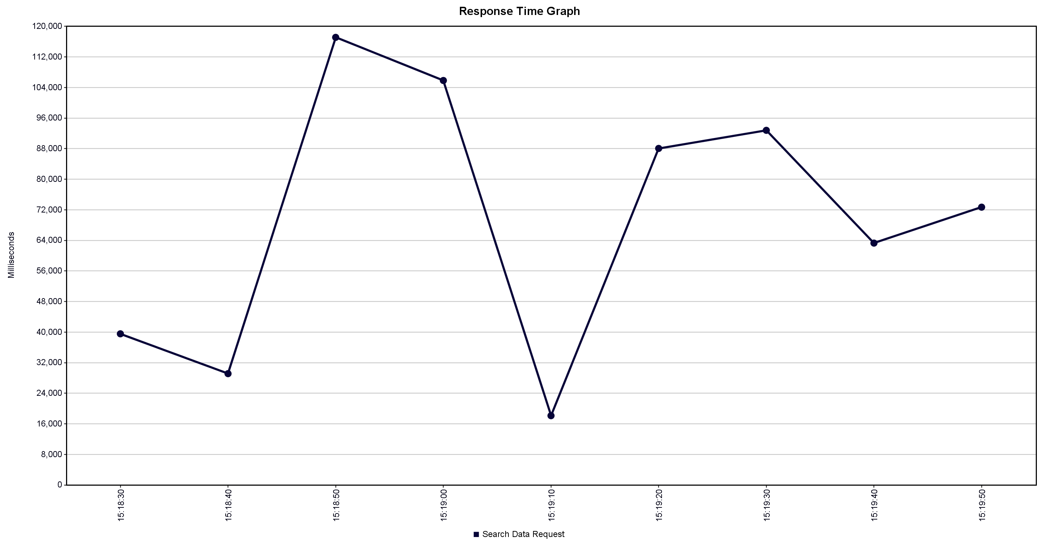

Error Rate : 30%
Throughput : 0.06545 requests/seconds
Discussion of Results: As visible in the graph above, since we haven’t implemented a message queue, and since the ramp up period is lesser than the average response time of the service, we get a 30% failure rate.

3) Radar Service with 4 instances
Test Context : Service Tested Independently.
Ramp Up Period : 100 seconds
Threads/Users : 10

Results: Response Time Graph
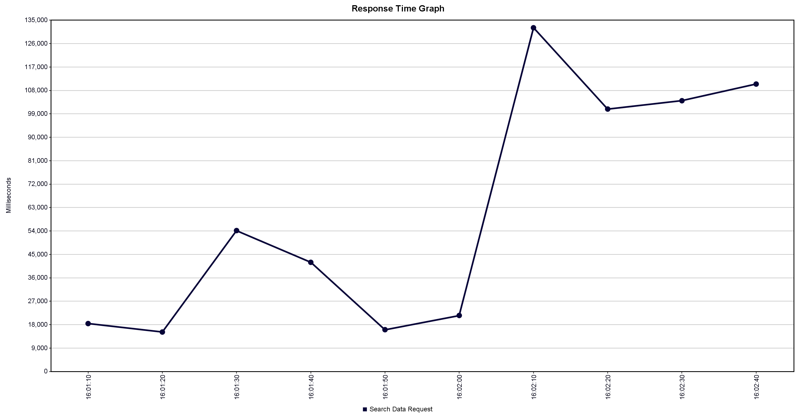

Error Rate: 10%
Throughput : 0.05039 requests/seconds
Discussion of Results: Addition of an instance decreases the error rate even further down to 10%. 9 out of 10 requests succeeded. However, even with 4 instances running, system couldn’t handle all requests which shows the importance of Message Queues.
The error rates are seen due to less resources available on the system and takes more time to compute. For the same reason, the throughput is also low

B] Authentication, Profile , History and Gateway micro-services test

1: All micro-services with 3 instances
Test Plan Description :
a) Register Request : User will register using his email address, name and password.
b) Login Request: User will login into the application using his credentials
c) Set Cookie: After login, user gets a cookie as a response which is needed for further calls.
d) Get Profile Request: User profile details are returned.
e) Add Search History: The parameters searched for the weather service will be added to MySQL database
f) Get Search History: User search history will be returned
g) Logout: User will be logged out

Ramp Up Period: 5 seconds
Threads/Users: 1000

Results:

I) Aggregate Graph – Response times of all services
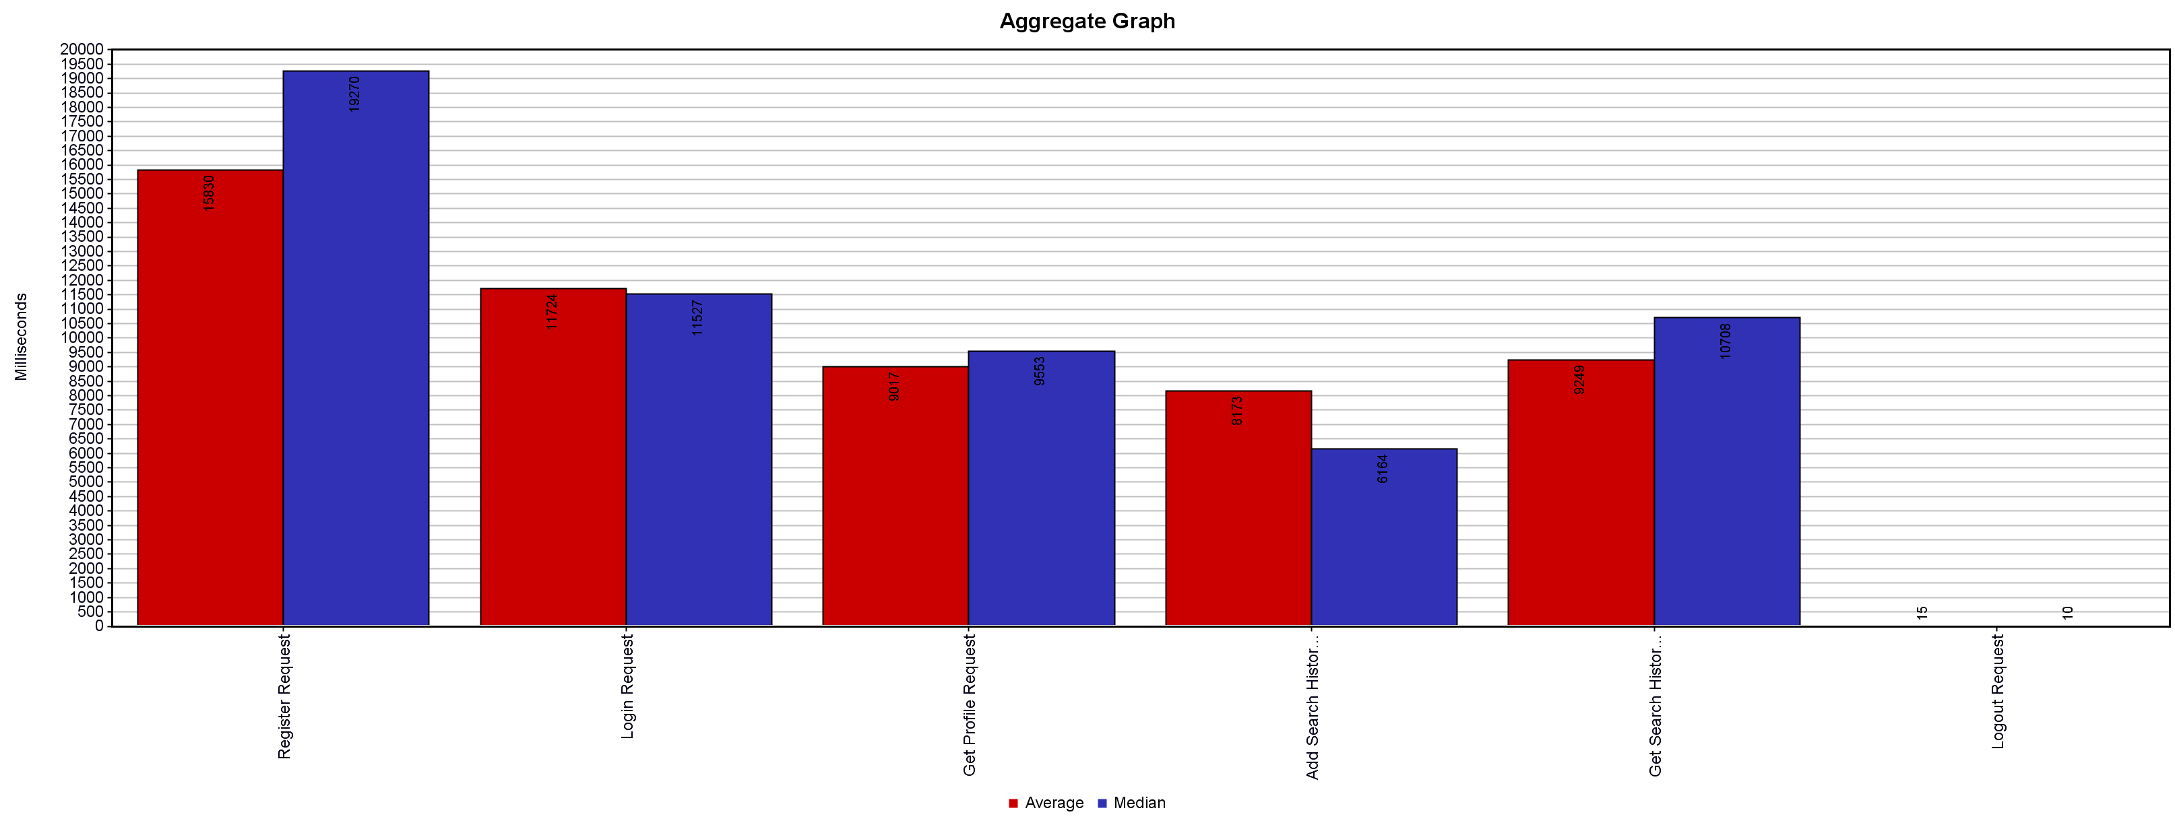

II) Real time running Graph Result

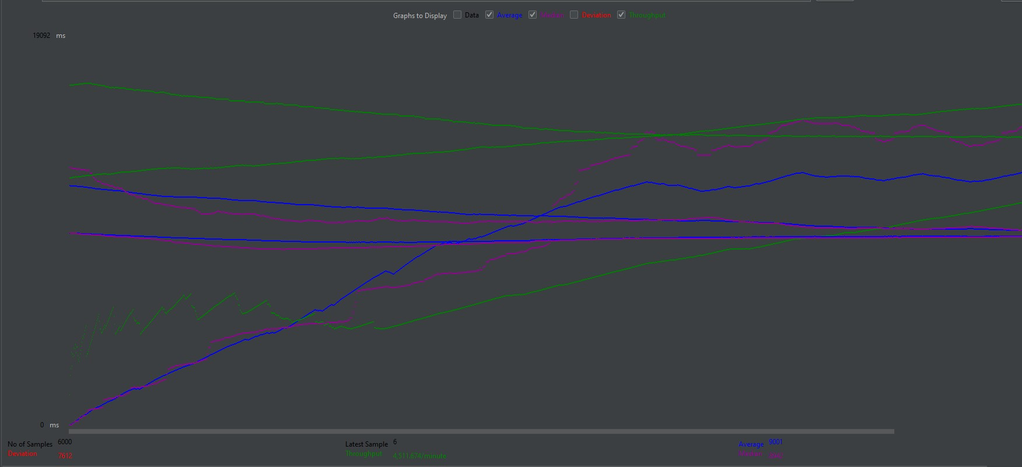

III) Response-Time Results
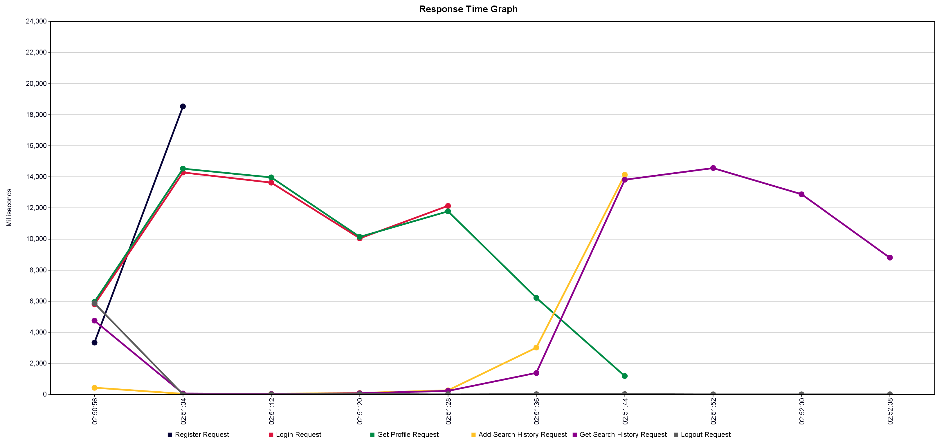

IV) Tabular Results

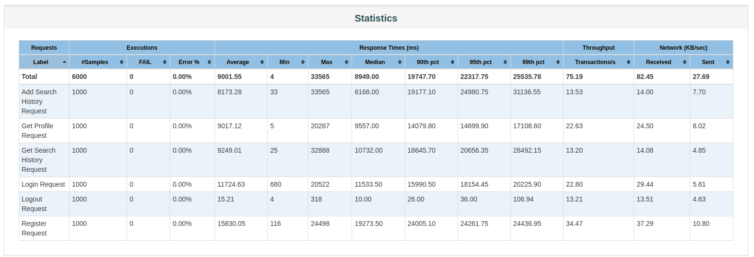
Discussion of Results: Since the ramp up period is only 5 seconds, 200 users will be active and sending concurrent register request first as part of the test plan, Hence, the register requests finish the earliest as visible from the Response Time Graphs.

2: All Microservices with 3 instances
Ramp Up Period : 30 seconds
Threads/Users: 1000

Results:

I) Aggregate Graph
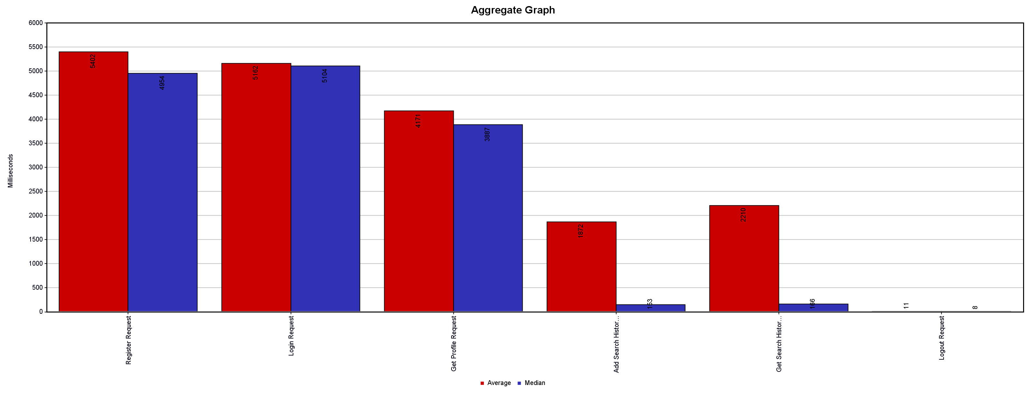

II) Response Time Graph
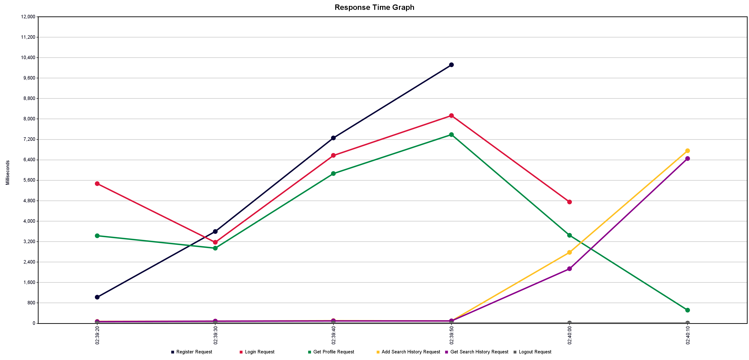

III) Real-time Throughput Graph Results

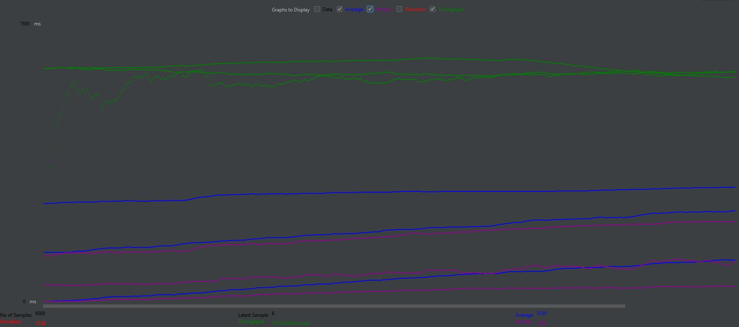

Error Rate: 0%
Throughput : The table shows the throughput
Label | Average | Min | Max | Std. Dev. | Error % | Throughput | Received KB/sec | Sent KB/sec | Avg. Bytes
Register Request | 5402 | 45 | 16564 | 3508.26 | 0.000% | 23.97 | 25.93 | 7.51 | 1108
Login Request | 5162 | 36 | 13837 | 3013.04 | 0.000% | 21.12 | 27.26 | 5.38 | 1322
Get Profile Request | 4171 | 6 | 12563 | 2717.04 | 0.000% | 21 | 22.75 | 7.45 | 1108.9
Add Search History Request | 1872 | 30 | 16996 | 2699.1 | 0.000% | 16.74 | 17.31 | 9.53 | 1059
Get Search History Request | 2210 | 24 | 14420 | 3018.17 | 0.000% | 16.21 | 18.1 | 5.95 | 1143.6
Logout Request | 11 | 3 | 129 | 9.87 | 0.000% | 16.22 | 16.59 | 5.69 | 1047
TOTAL | 3138 | 3 | 16996 | 3358.91 | 0.000% | 96.97 | 107.15 | 35.71 | 1131.4

Discussion of Results: Since the ramp up period now increased, we get a better throughput of the application with no spikes visible in the real-time graph above. The response times also decreased for all requests due to the increased ramp-up period

3: All Microservices with 5 instances

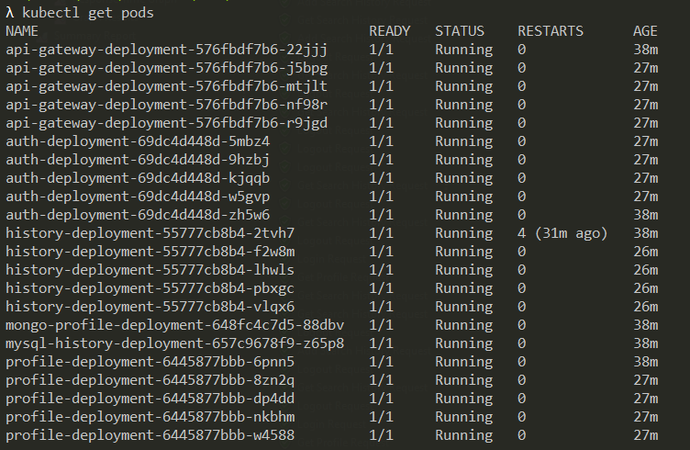

Ramp Up Period: 1 second
Threads/Users: 1000
Results:
I) Aggregate Graph:

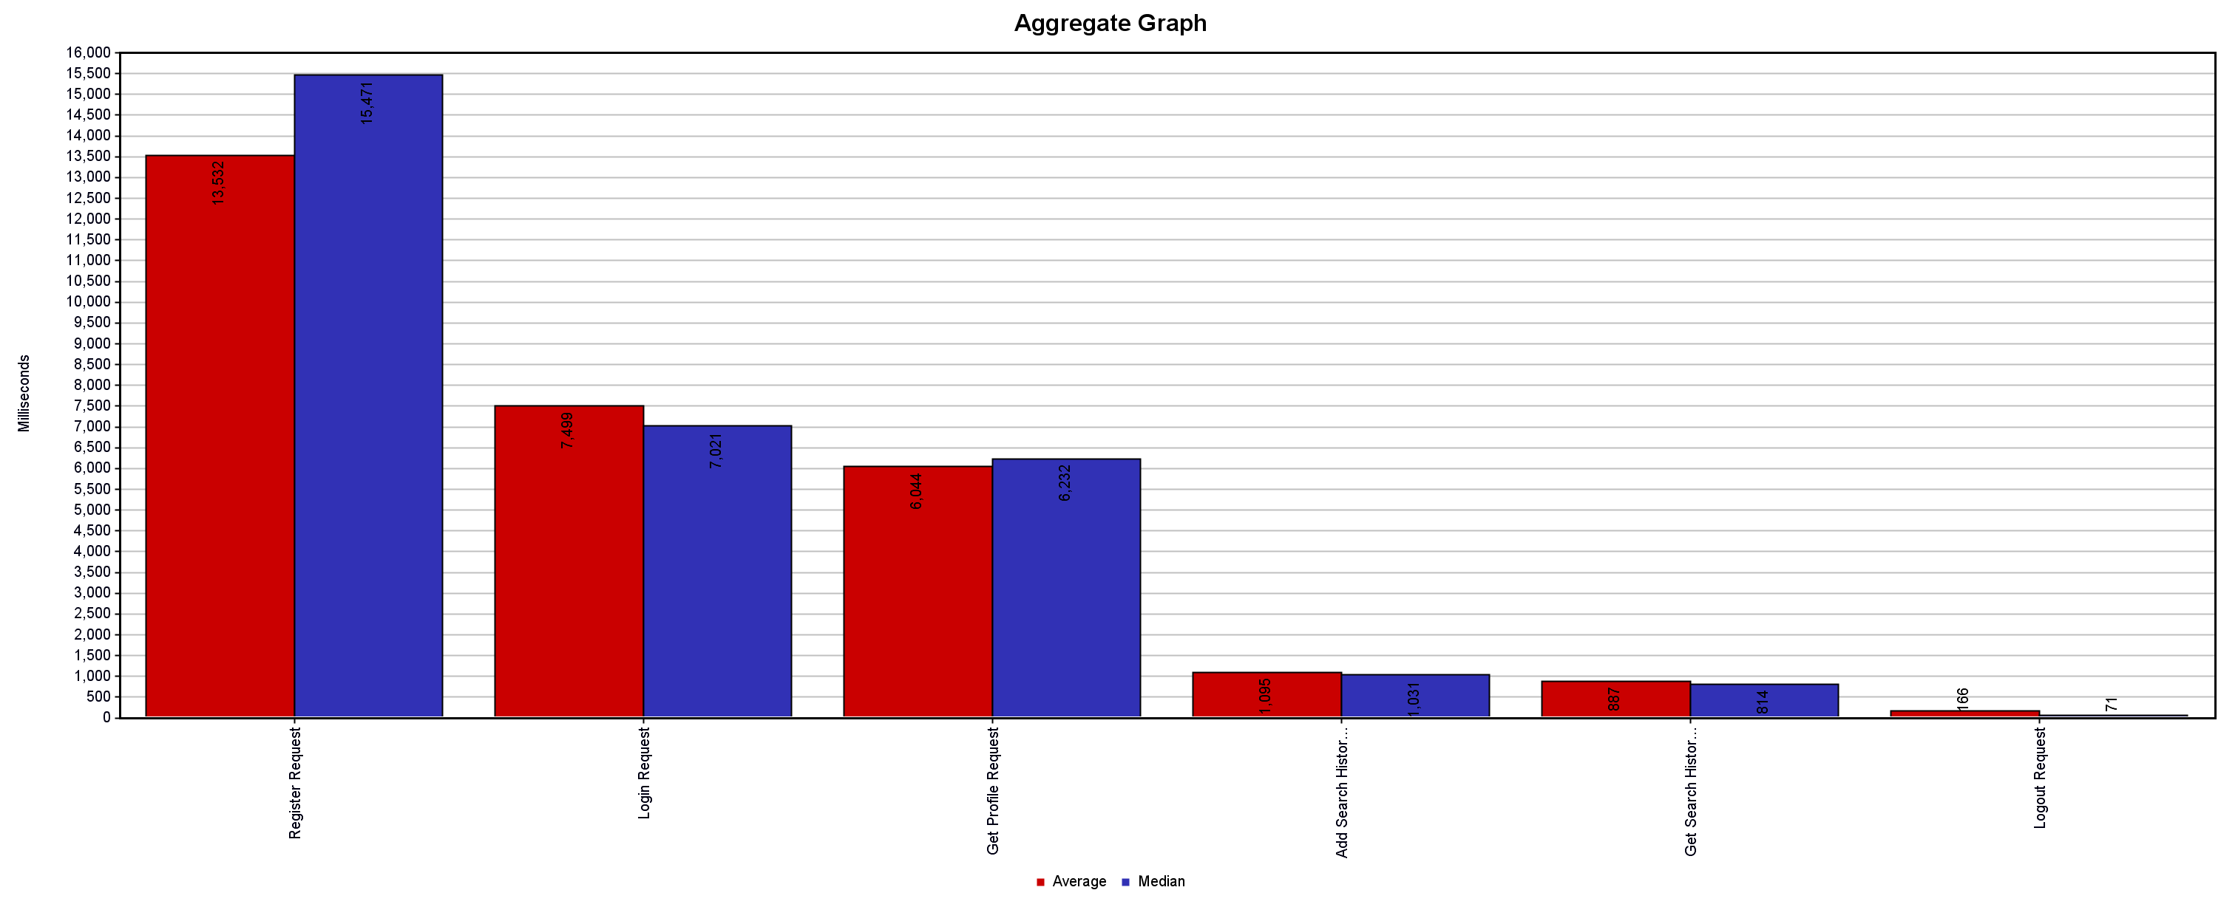

II) Response Time Results :
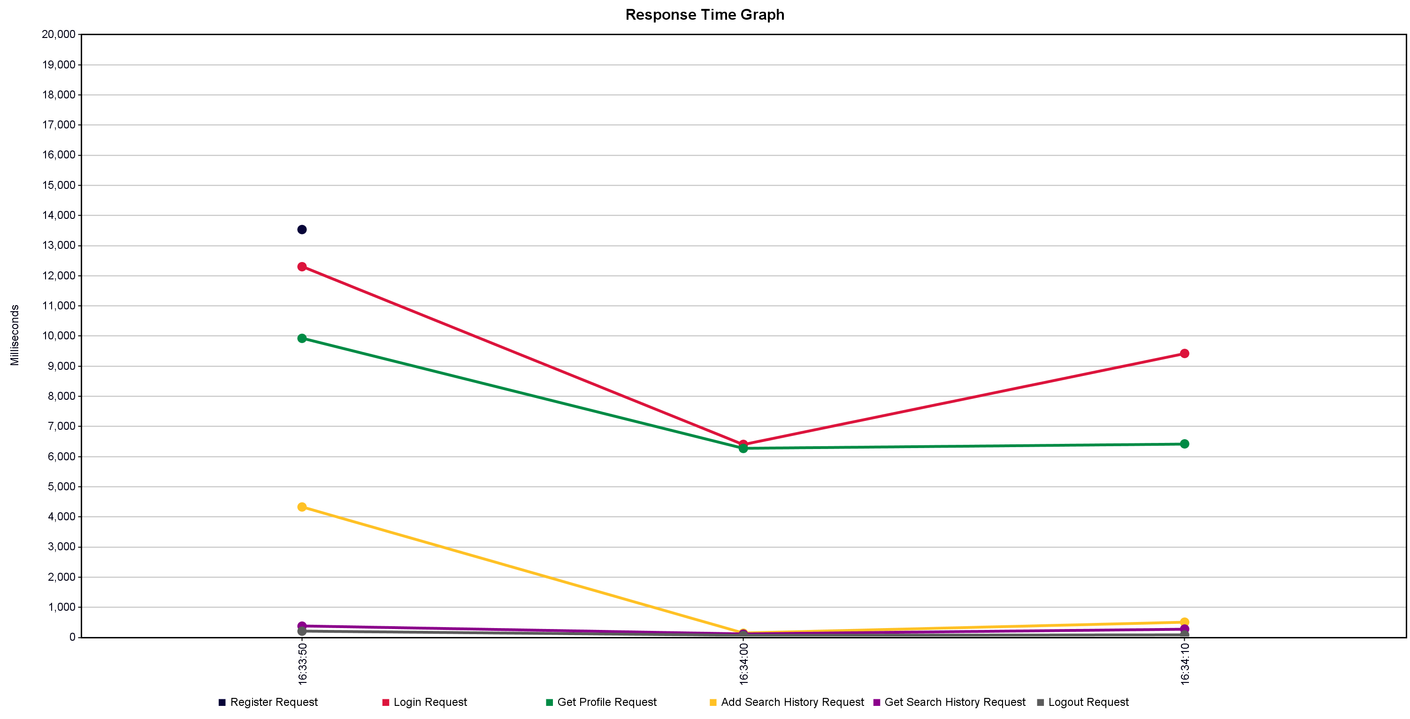

Error Rate: 0%

Throughput: The following table shows the throughput
Label | Average | Min | Max | Std. Dev. | Error % | Throughput | Received KB/sec | Sent KB/sec | Avg. Bytes
Register Request | 13532 | 685 | 19597 | 5064.31 | 0.000% | 49.37 | 53.42 | 15.47 | 1108
Login Request | 7499 | 1285 | 14278 | 2789.02 | 0.000% | 31.76 | 41.01 | 8.1 | 1322
Get Profile Request | 6044 | 27 | 12429 | 2806.35 | 0.000% | 35.39 | 38.33 | 12.55 | 1108.9
Add Search History Request | 1095 | 15 | 4065 | 903.51 | 0.000% | 47.42 | 49.05 | 27 | 1059
Get Search History Request | 887 | 9 | 4394 | 752.1 | 0.000% | 46.91 | 51.07 | 17.22 | 1114.9
Logout Request | 166 | 3 | 1489 | 221.99 | 0.000% | 46.9 | 47.95 | 16.44 | 1047
TOTAL | 4871 | 3 | 19597 | 5451.36 | 0.000% | 166.55 | 183.24 | 61.34 | 1126.6

Discussion of Results: Since all users concurrently access the system, the register api is severely overwhelmed which is why it has the most response time.

3: All Micro-services with 5 instances (Pre-existing Users)
Ramp Up Period : 3 seconds
Loop Count: 10
Threads/Users: 1000

Results:

I) Aggregate Graph

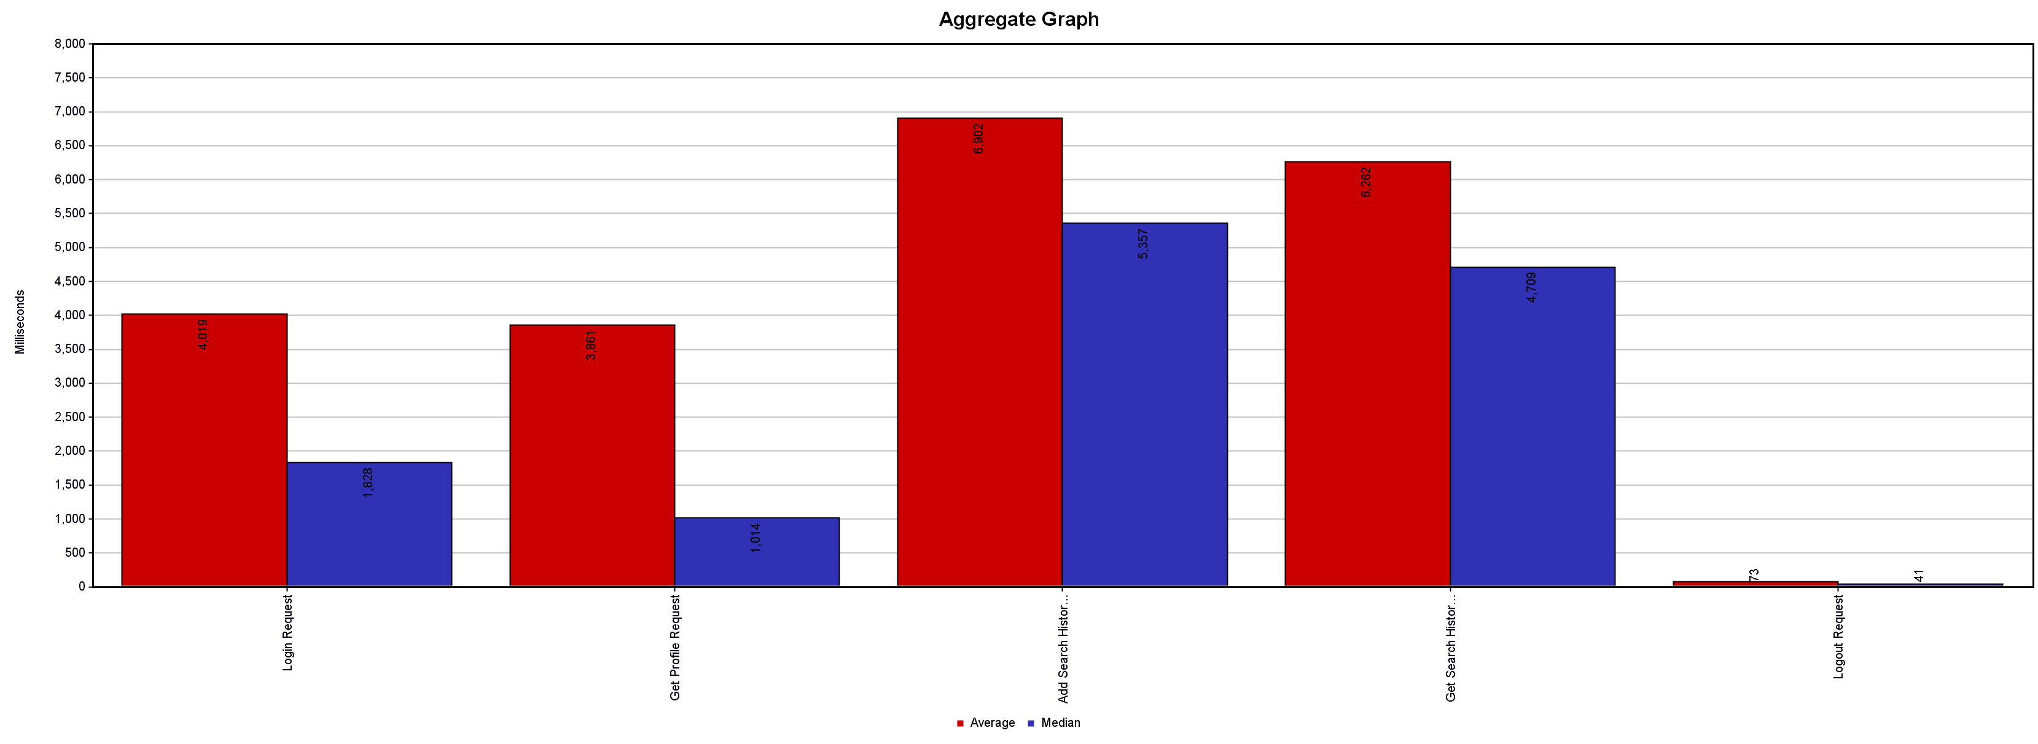

II) Response Time Graph
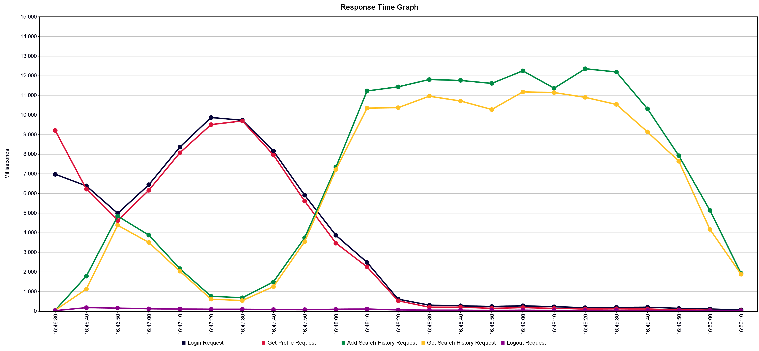

III) Real-Time Throughput Graph Result
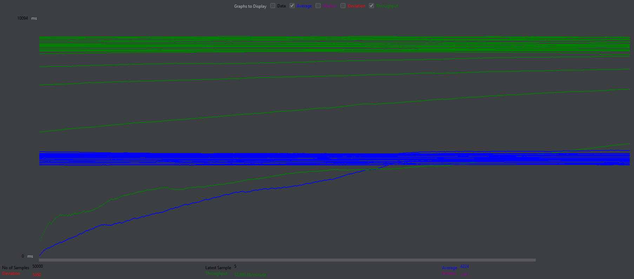

Error Rate : 0%
Throughput : The below table shows the throughput of the services
Label | Average | Min | Max | Std. Dev. | Error % | Throughput | Received KB/sec | Sent KB/sec | Avg. Bytes
Login Request | 4019 | 29 | 19479 | 4470.58 | 0.000% | 42.94 | 55.44 | 10.95 | 1322
Get Profile Request | 3861 | 4 | 18051 | 4482.18 | 0.000% | 42.96 | 46.52 | 15.23 | 1108.9
Add Search History Request | 6902 | 14 | 37829 | 6156.87 | 0.000% | 43.04 | 44.52 | 24.5 | 1059.2
Get Search History Request | 6262 | 10 | 37596 | 6035.41 | 0.000% | 43.06 | 54.82 | 15.81 | 1303.5
Logout Request | 73 | 3 | 1598 | 91.38 | 0.000% | 43.12 | 44.09 | 15.12 | 1047
TOTAL | 4224 | 3 | 37829 | 5350.65 | 0.000% | 214.67 | 244.88 | 81.42 | 1168.1

Discussion of Results: Since the ramp up period was increased, we got a steady through as visible in the live graph results. The number of requests being served simultaneously was steady and hence all requests executed correctly.

C] Fault Tolerance and Elastic Scalability

Loop Count: Infinite
Thread/Users: 1000
Ramp Up Period: 30 seconds

Test Procedure : The Loop count was set to infinite.
The micro-services containers were stopped 1 at a time
The services were then restarted and the response time was monitored

Results:
I] Aggregate Results

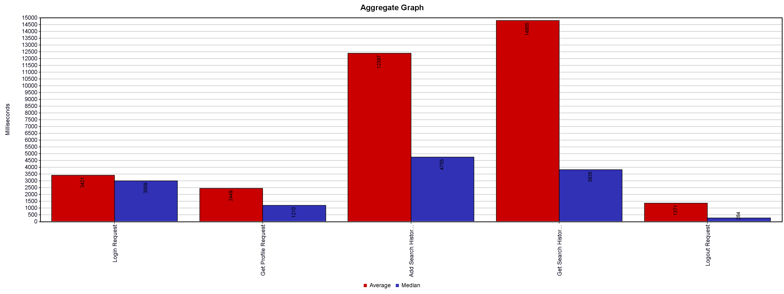

II] Response Time Graph

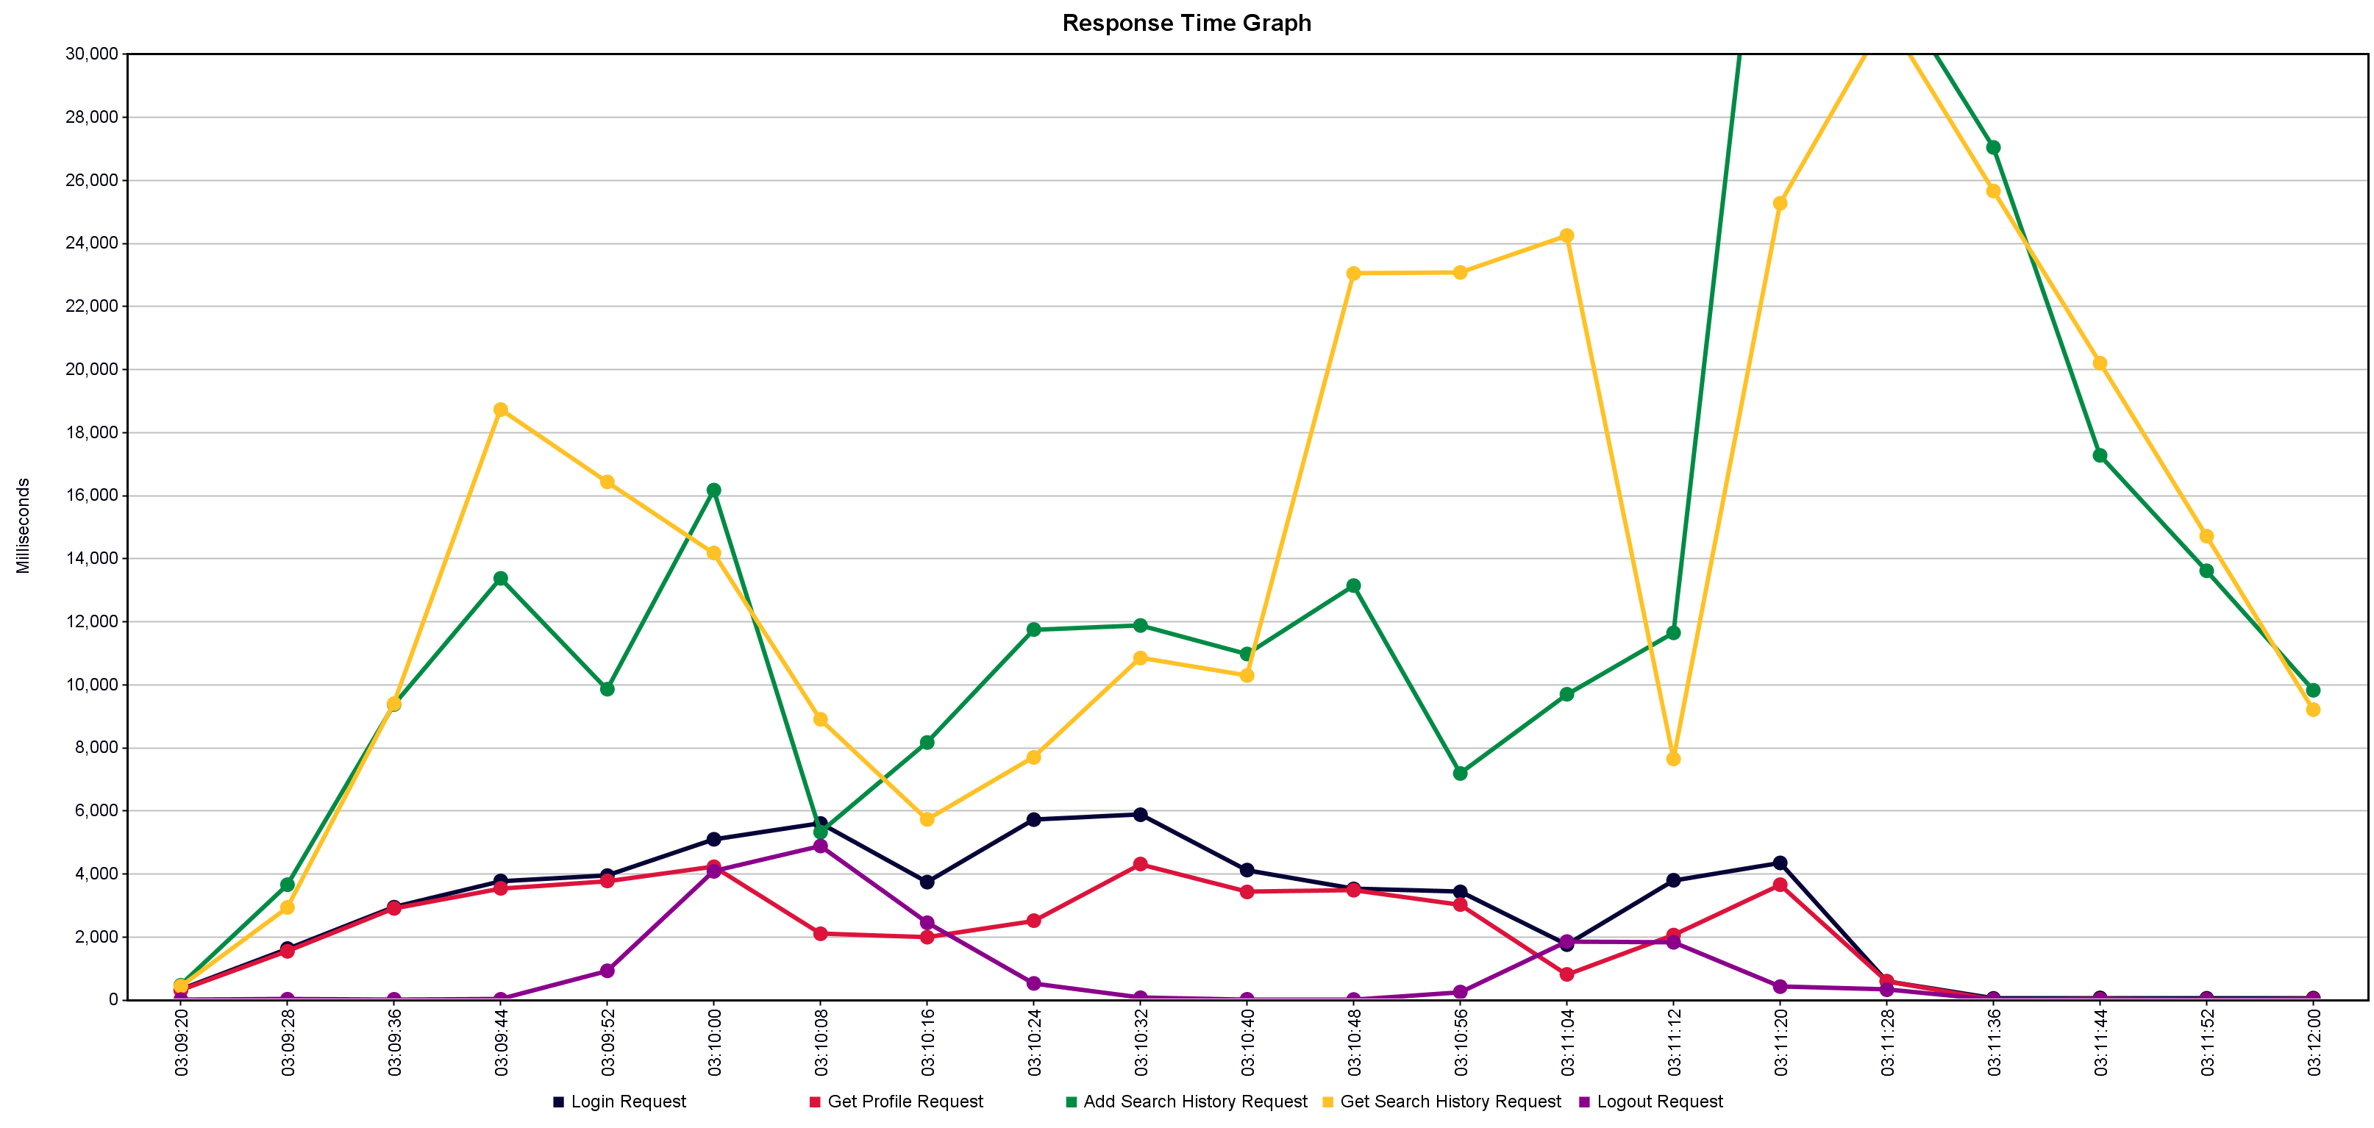

III] Real-time Throughput Results:
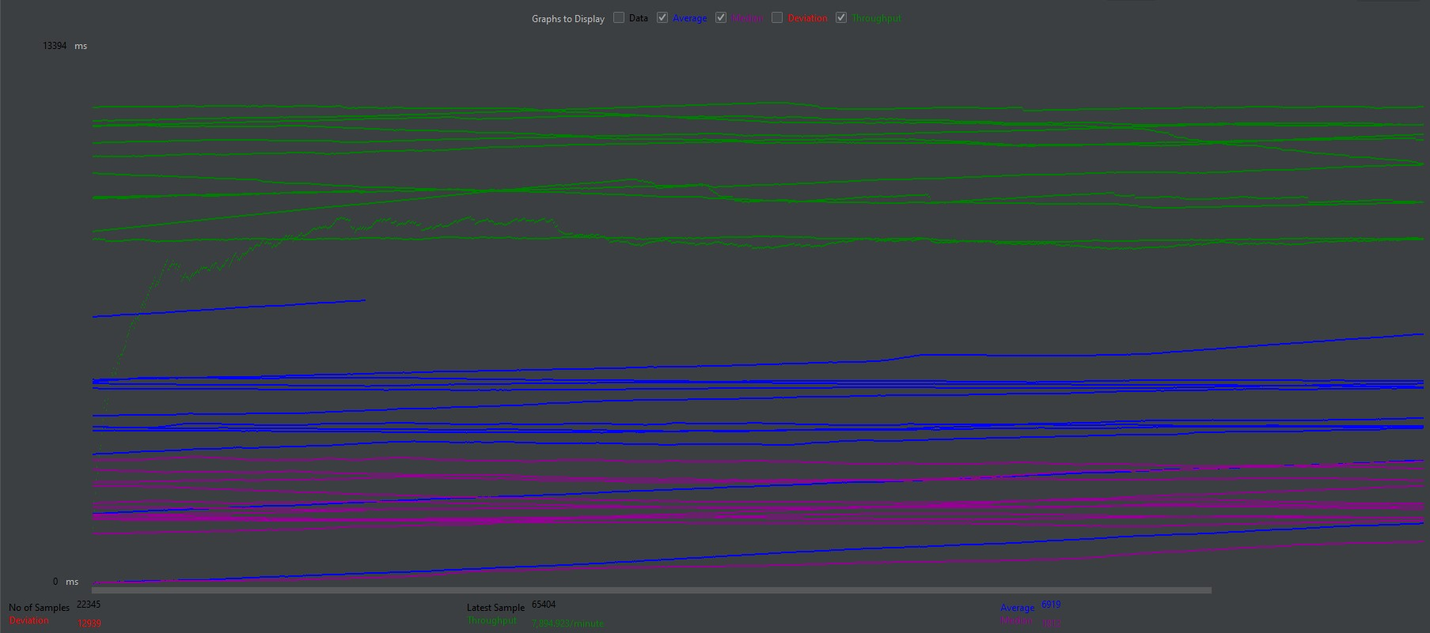
IV] Error Rate Pie Chart
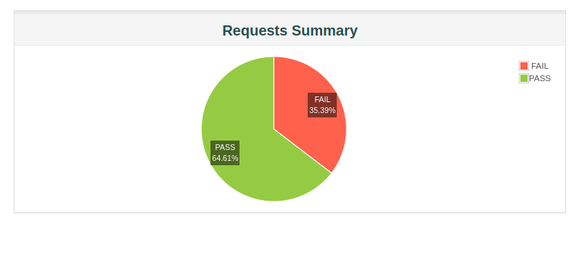

V] Throughput Statistics
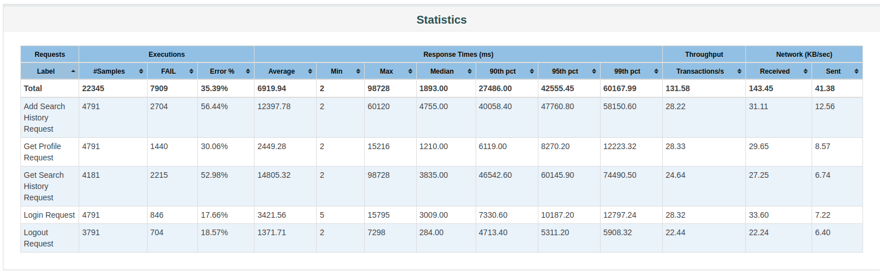

VI] Request vs Response Time Scatter Plot

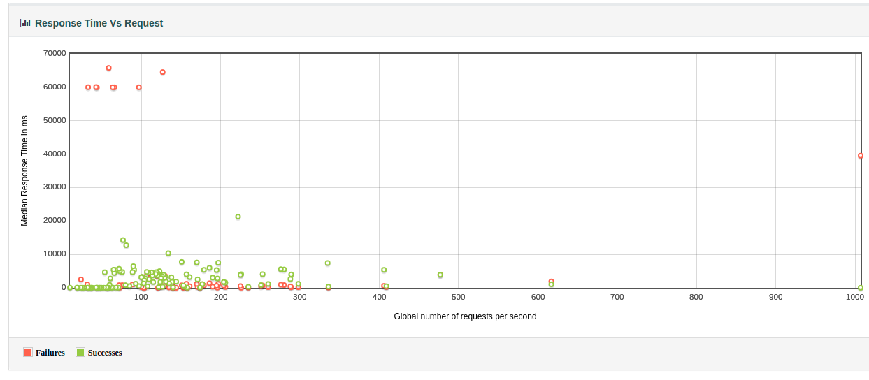
Discussion of Results:

As we can see, the error rate of the system was 35% which means our application seemed to work even when the services stopped. Once the services came back up, the response time came down which is clearly visible in the graphs.

